Table of Contents

1 System Block Diagram 1

2 Static Design 2

2.1Layered Architecture Design 2

1.1ECU 1 3

1.1.1 Component and Modules 3

1.1.2 APIs Description 3

1.1.3 Folder Structure 8

1.2ECU 2 10

1.2.1 Component and Modules 10

1.2.2 APIs Description 10

1.2.3 Folder Structure 14

2 Dynamic Design 15

2.1ECU 1 15

2.1.1 ECU components state machines 15

2.1.2 ECU state machine 15

2.2ECU 2 15

2.2.1 ECU components state machines 15

2.2.2 ECU state machine 15

1. System Block Diagram

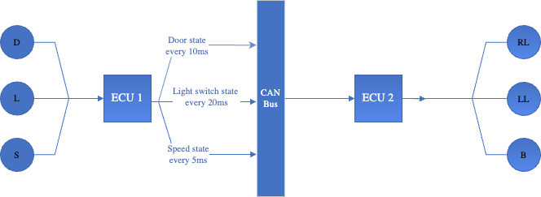

1. Static Design
   1. Layered Architecture Design

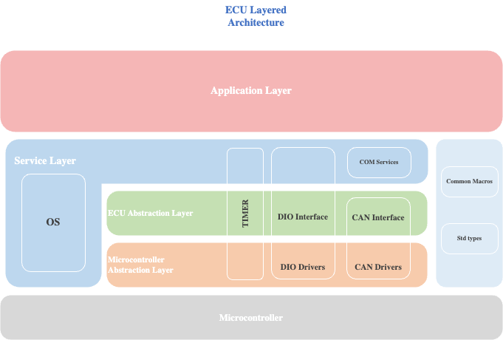

* 1. ECU 1
     1. Component and Modules

|  |  |  |  |
| --- | --- | --- | --- |
| MCAL | | ECU Abstraction Layer | |
| **DIO APIs** | * Initialize * read * write | **Door Sensor APIs** | * Initialize * Read |
| **Timer APIs** | * Initialize * Start * Stop | **Light Switch APIs** | * Initialize * Read |
| **CAN APIs** | * Initialize * Send * Receive | **Speed Sensor APIs** | * Initialize * Read |
| **ADC APIs** | * Initialize * Read |

* + 1. APIs Description

**DIO APIs:**

|  |  |  |  |
| --- | --- | --- | --- |
| Function name | DIO_Init | | |
| Arguments | Inputs | pinConfig | DIO_pinConfig * |
|  | array of pins configuration | |
| Output | N/A | |
| Input/Output | N/A |  |
| Return | E_OK | 0 | |
| E_NOK | 1 | |
| Description | Initialize ports according to the configurations in DIO_Config.c | | |

|  |  |  |  |
| --- | --- | --- | --- |
| Function name | DIO_Read | | |
| Arguments | Inputs | channel | Gpio_ChannelType |
| the channel to be read | |
| Output | uint8 | channel value |
| Input/Output | N/A | |
| Return | uint8 | pin value | |
| Description | Reads the value of a certain pin in a port (channel) | | |

|  |  |  |  |
| --- | --- | --- | --- |
| Function name | DIO_Write | | |
| Arguments | Inputs | channel | Gpio_ChannelType |
| the channel to be read | |
| Output | N/A | |
| Input/Output |  | |
| Return | uint8 | pin value | |
| Description | Reads the value of a certain pin in a port (channel) | | |

|  |  |  |
| --- | --- | --- |
| Name | DIO_pinConfig | |
| Type | Struct | |
| Elements | channel | channel port and pin |
| pinMode | the mode of the pin |
| pinValue | the initial value of the pin |
| pinDirection | the direction of the pin |
| Description | pin configuration used for initializing a pin | |

|  |  |  |
| --- | --- | --- |
| Name | Gpio_ChannelType | |
| Type | Struct | |
| Elements | port | channel port |
| pin | channel pin |
| Description | pin configuration used for initializing a pin | |

**ADC APIs:**

|  |  |  |  |
| --- | --- | --- | --- |
| Function name | ADC_Init | | |
| Arguments | Inputs | pinConfig | DIO_pinConfig * |
|  | array of pins configuration | |
| Output | N/A | |
| Input/Output | N/A |  |
| Return | E_OK | 0 | |
| E_NOK | 1 | |
| Description | Initialize ports according to the configurations in DIO_Config.c | | |

|  |  |  |  |
| --- | --- | --- | --- |
| Function name | ADC_Read | | |
| Arguments | Inputs | channel | Gpio_ChannelType |
| the channel to be read | |
| Output | uint8 | channel value |
| Input/Output | N/A | |
| Return | uint32 | pin value | |
| Description | Reads the value of a certain pin in a port (channel) | | |

**Timer APIs:**

|  |  |  |  |
| --- | --- | --- | --- |
| Function name | Timer_Init | | |
| Arguments | Inputs | timerConfig | Timer_configType |
|  | Configuration structure | |
| Output | N/A | |
| Input/Output | N/A |  |
| Return | E_OK | 0 | |
| E_NOK | 1 | |
| Description | Initialize a timer | | |

|  |  |  |  |
| --- | --- | --- | --- |
| Function name | Timer_start | | |
| Arguments | Inputs | channel | uint_8 |
| Timer channel to be stated | |
| time | Uint_32 |
| The time for the timer | |
| Output | N/A |  |
| Input/Output | N/A | |
| Return | E_OK | 0 | |
| E_NOK | 1 | |
| Description | Starts a given timer with a given time | | |

|  |  |  |  |
| --- | --- | --- | --- |
| Function name | Timer_stop | | |
| Arguments | Inputs | channel | uint_8 |
| Timer channel to be stopped | |
| Output | N/A |  |
| Input/Output | N/A | |
| Return | E_OK | 0 | |
|  | E_NOK | 1 | |
| Description | Stops a given timer | | |

**CAN APIs:**

|  |  |  |  |
| --- | --- | --- | --- |
| Function name | CAN_Init | | |
| Arguments | Inputs | config | CAN_configType |
|  | Configuration structure | |
| Output | N/A | |
| Input/Output | N/A |  |
| Return | E_OK | 0 | |
| E_NOK | 1 | |
| Description | Initialize the CAN communication | | |

|  |  |  |  |
| --- | --- | --- | --- |
| Function name | CAN_sendData | | |
| Arguments | Inputs | data | uint8 |
| The data to be sent | |
| Output | N/A |  |
| Input/Output | N/A | |
| Return | E_OK | 0 | |
| E_NOK | 1 | |
| Description | Sends data over CAN bus | | |

|  |  |  |  |
| --- | --- | --- | --- |
| Function name | CAN_receiveData | | |
| Arguments | Inputs | id | uint8 |
| Data ID | |
| Output | N/A | |
| Input/Output | N/A | |
| Return | uint8 | Data received | |
| Description | Recieves data from the CAN bus | | |

**Door Sensor APIs:**

|  |  |  |  |
| --- | --- | --- | --- |
| Function name | DoorSensor_Init | | |
| Arguments | Inputs | config | Door_configType |
|  | Configuration structure | |
| Output | N/A | |
| Input/Output | N/A |  |
| Return | E_OK | 0 | |
| E_NOK | 1 | |
| Description | Initialize the door sensor | | |

|  |  |  |  |
| --- | --- | --- | --- |
| Function name | DoorSensor_ReadValue | | |
| Arguments | Inputs | channel | Uint8 |
| The door sensor to be read value from | |
| Output | N/A | |
| Input/Output | N/A | |
| Return | uint8 | Sensor value | |
| Description | Reads the value of the door sensor | | |

**Light Switch APIs:**

|  |  |  |  |
| --- | --- | --- | --- |
| Function name | LightSW_Init | | |
| Arguments | Inputs | config | LightSW_configType |
|  | Configuration structure | |
| Output | N/A | |
| Input/Output | N/A |  |
| Return | E_OK | 0 | |
| E_NOK | 1 | |
| Description | Initialize the light switch | | |

|  |  |  |  |
| --- | --- | --- | --- |
| Function name | LightSW_ReadValue | | |
| Arguments | Inputs | channel | Uint8 |
| The light switch to be read value from | |
| Output | N/A | |
| Input/Output | N/A | |
| Return | Uint8 | Switch state | |
| Description | Reads the state of the light switch | | |

**Speed Sensor APIs:**

|  |  |  |  |
| --- | --- | --- | --- |
| Function name | SpeedSensor_Init | | |
| Arguments | Inputs | config | Speed_configType |
|  | Configuration structure | |
| Output | N/A | |
| Input/Output | N/A |  |
| Return | E_OK | 0 | |
| E_NOK | 1 | |
| Description | Initialize the speed sensor | | |

|  |  |  |  |
| --- | --- | --- | --- |
| Function name | SpeedSensor_ReadValue | | |
| Arguments | Inputs | channel | Uint8 |
| The speed sensor to be read value from | |
| Output | N/A | |
| Input/Output | N/A | |
| Return | Uint32 | Sensor value | |
| Description | Reads the value of the speed sensor | | |

* + 1. Folder Structure

/ECU1/MCAL/

/ECU1/MCAL/Inc/

/ECU1/HAL/

/ECU1/HAL/Inc/

/ECU1/APP/

/ECU1/APP/Inc

/ECU1/Config

/ECU1/Service

/ECU1/Common

* 1. ECU 2
     1. Component and Modules

|  |  |  |  |
| --- | --- | --- | --- |
| MCAL | | ECU Abstraction Layer | |
| **DIO APIs** | * Initialize * read * write | **Lights APIs** | * Initialize * on * off |
| **Timer APIs** | * Initialize * Start * Stop | **Buzzer APIs** | * Initialize * on * off |
| **CAN APIs** | * Initialize * Send * Receive |  |  |

* + 1. APIs Description

**DIO APIs:**

|  |  |  |  |
| --- | --- | --- | --- |
| Function name | DIO_Init | | |
| Arguments | Inputs | pinConfig | DIO_pinConfig * |
|  | array of pins configuration | |
| Output | N/A | |
| Input/Output | N/A |  |
| Return | E_OK | 0 | |
| E_NOK | 1 | |
| Description | Initialize ports according to the configurations in DIO_Config.c | | |

|  |  |  |  |
| --- | --- | --- | --- |
| Function name | DIO_Read | | |
| Arguments | Inputs | channel | Gpio_ChannelType |
| the channel to be read | |
| Output | uint8 | channel value |
| Input/Output | N/A | |
| Return | uint8 | pin value | |
| Description | Reads the value of a certain pin in a port (channel) | | |

|  |  |  |  |
| --- | --- | --- | --- |
| Function name | DIO_Write | | |
| Arguments | Inputs | channel | Gpio_ChannelType |
| the channel to be read | |
| Output | N/A | |
| Input/Output |  | |
| Return | uint8 | pin value | |
| Description | Reads the value of a certain pin in a port (channel) | | |

|  |  |  |
| --- | --- | --- |
| Name | DIO_pinConfig | |
| Type | Struct | |
| Elements | channel | channel port and pin |
| pinMode | the mode of the pin |
| pinValue | the initial value of the pin |
| pinDirection | the direction of the pin |
| Description | pin configuration used for initializing a pin | |

|  |  |  |
| --- | --- | --- |
| Name | Gpio_ChannelType | |
| Type | Struct | |
| Elements | port | channel port |
| pin | channel pin |
| Description | pin configuration used for initializing a pin | |

**Timer APIs:**

|  |  |  |  |
| --- | --- | --- | --- |
| Function name | Timer_Init | | |
| Arguments | Inputs | timerConfig | Timer_configType |
|  | Configuration structure | |
| Output | N/A | |
| Input/Output | N/A |  |
| Return | E_OK | 0 | |
| E_NOK | 1 | |
| Description | Initialize a timer | | |

|  |  |  |  |
| --- | --- | --- | --- |
| Function name | Timer_start | | |
| Arguments | Inputs | channel | uint_8 |
| Timer channel to be stated | |
| time | Uint_32 |
| The time for the timer | |
| Output | N/A |  |
| Input/Output | N/A | |
| Return | E_OK | 0 | |
| E_NOK | 1 | |
| Description | Starts a given timer with a given time | | |

|  |  |  |  |
| --- | --- | --- | --- |
| Function name | Timer_stop | | |
| Arguments | Inputs | channel | uint_8 |
| Timer channel to be stopped | |
| Output | N/A |  |
| Input/Output | N/A | |
| Return | E_OK | 0 | |
| E_NOK | 1 | |
| Description | Stops a given timer | | |

**CAN APIs:**

|  |  |  |  |
| --- | --- | --- | --- |
| Function name | CAN_Init | | |
| Arguments | Inputs | config | CAN_configType |
|  | Configuration structure | |
| Output | N/A | |
| Input/Output | N/A |  |
| Return | E_OK | 0 | |
| E_NOK | 1 | |
| Description | Initialize the CAN communication | | |

|  |  |  |  |
| --- | --- | --- | --- |
| Function name | CAN_sendData | | |
| Arguments | Inputs | data | uint8 |
| The data to be sent | |
| Output | N/A |  |
| Input/Output | N/A | |
| Return | E_OK | 0 | |
| E_NOK | 1 | |
| Description | Sends data over CAN bus | | |

|  |  |  |  |
| --- | --- | --- | --- |
| Function name | CAN_receiveData | | |
| Arguments | Inputs | id | uint8 |
| Data ID | |
| Output | N/A | |
| Input/Output | N/A | |
| Return | uint8 | Data received | |
| Description | Receives data from the CAN bus | | |

**Light APIs:**

|  |  |  |  |
| --- | --- | --- | --- |
| Function name | Light_Init | | |
| Arguments | Inputs | config | Light_configType |
|  | Configuration structure | |
| Output | N/A | |
| Input/Output | N/A |  |
| Return | E_OK | 0 | |
| E_NOK | 1 | |
| Description | Initialize the lights | | |

|  |  |  |  |
| --- | --- | --- | --- |
| Function name | Light_On | | |
| Arguments | Inputs | channel | Uint8 |
| The light to be turned on | |
| Output | N/A |  |
| Input/Output | N/A | |
| Return | E_OK | 0 | |
| E_NOK | 1 | |
| Description | Turns on the light given | | |

|  |  |  |  |
| --- | --- | --- | --- |
| Function name | Light_Off | | |
| Arguments | Inputs | channel | Uint8 |
| The light to be turned on | |
| Output | N/A |  |
| Input/Output | N/A | |
| Return | E_OK | 0 | |
| E_NOK | 1 | |
| Description | Turns off the light given | | |

* + 1. Folder Structure

/ECU2/MCAL/

/ECU2/MCAL/Inc/

/ECU2/HAL/

/ECU2/HAL/Inc/

/ECU2/APP/

/ECU2/APP/Inc

/ECU2/Config

/ECU2/Service

/ECU2/Common

1. Dynamic Design
   1. ECU 1
      1. ECU components state machines

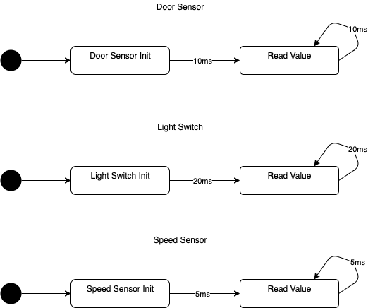

* + 1. ECU state machine

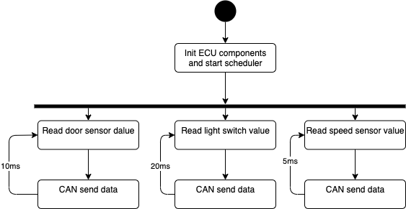

* + 1. ECU sequence diagram

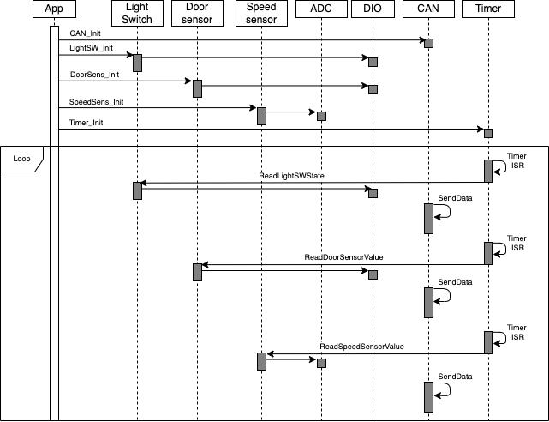

* 1. ECU 2
     1. ECU components state machines

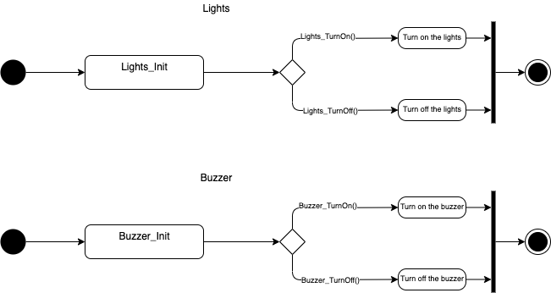

* + 1. ECU state machine

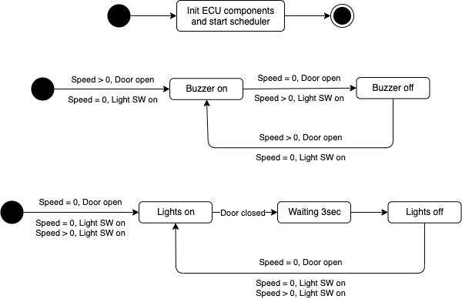

* + 1. ECU sequence diagram

